Preschool Activity Pages
Unit 15 • Session 6
Ezekiel Gave Hope
BIBLE STORY:
- God gave Ezekiel a vision of a valley filled with old, dry bones.
- God made the bones come to life.
- God said His people thought they were like those bones, but God planned to bring His people home and give them life.
KEY PASSAGE: 2 Chronicles 7:14
BIG PICTURE QUESTION:
- How did God plan to fix what sin broke? God planned to send Jesus.
FAMILY DISCUSSION STARTERS:
- Why did God’s people think they were like the bones God showed Ezekiel? How are we like the bones?
- Talk about what would it feel like to live far away from your home or your family.
- What does God give us when we turn from sin and trust in Jesus?
FAMILY ACTIVITY:
- Look online at a child-friendly diagram of the skeletal system. Help preschoolers feel and name their bones. Review the Bible story.
- Ask permission to pick up sticks in a neighbor’s yard. Read and review Ezekiel 37:15-19.
DOWNLOAD the
LIFEWAY KIDS APP
27
© 2019 LifeWay

Find the Differences
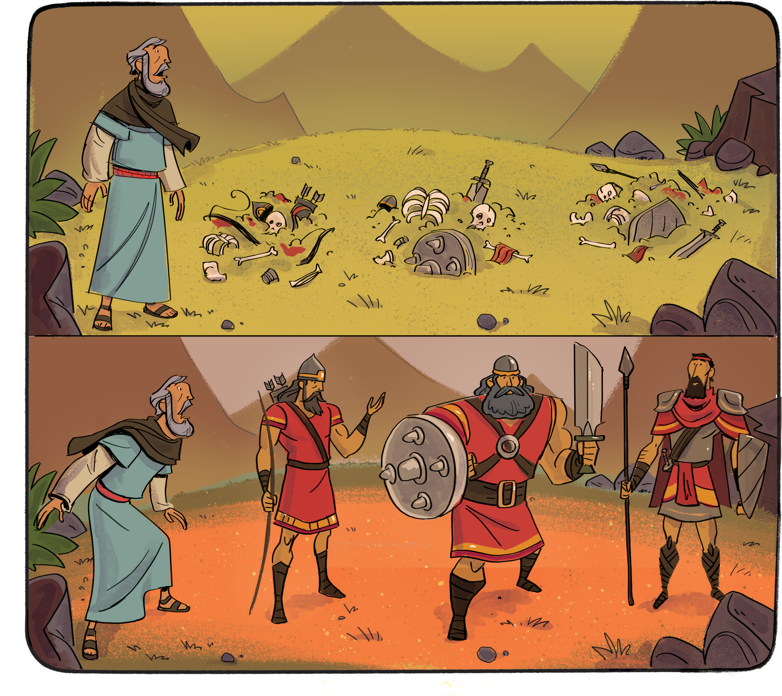
INSTRUCTIONS: Look at the two pictures and circle the differences in the bottom picture.

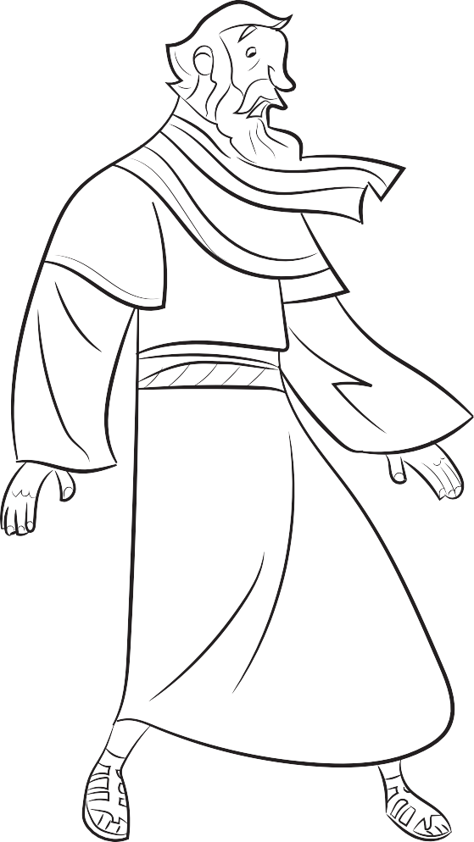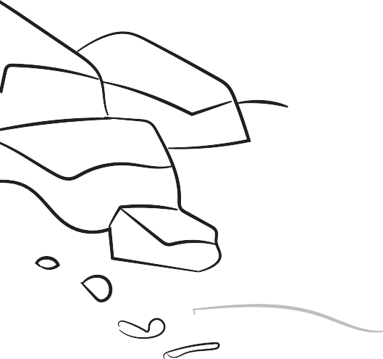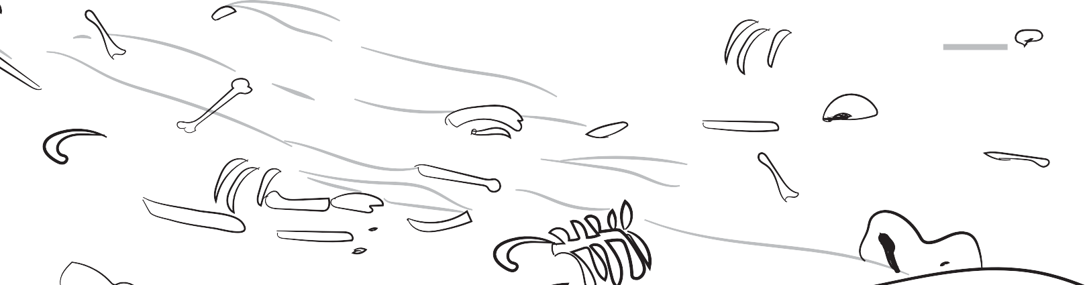

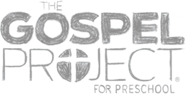
STORY POINT: GOD PLANNED TO BRING HIS PEOPLE HOME. ^{Ezekiel} ^{Gave} ^{Hope} 28
Ezekiel 37
© 2019 LifeWay

